Tracking my evaluation of HPVsim calibrations and why the GOF looks pretty bad when evaluating my base case
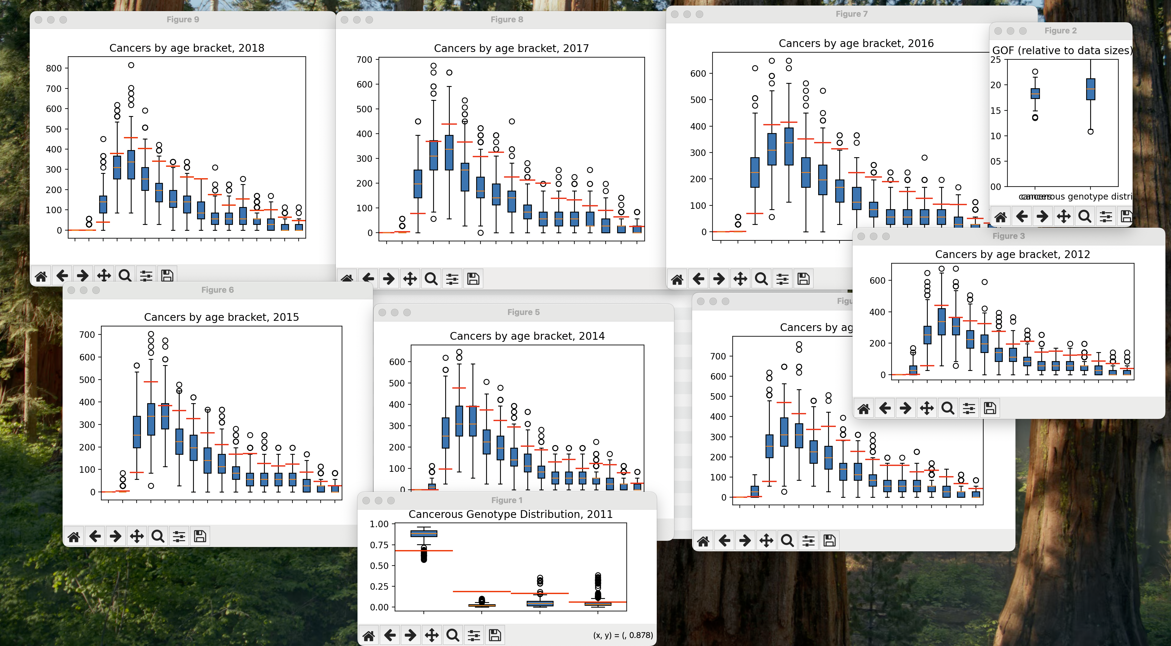
Info on total GOF:
min:0.2769544038562699
LQ:0.3507759648708343
median:0.37481245926008977
UQ:0.3951578994523314
max:0.444019590934395
(recall, this is for final pooled calibration project_modelling/calibration_results/FinalPooledCalibration_8_68_76_55_55_9_9__96_7_13.pickle)
And it said the len(final_cal_data)=44
- I am not sure why the evaluation GOF is so bad. I have checked and all the ‘real_world_data’ csv files do look to be scaled correctly, and importantly with a consistnet scaling (i.e. equal values saved) between the condensed 2012-2018 data and the separatyed 2012-2018 data.
- I have checked, and FinalPooledCalibration_8_68_76_55_55_9_9__96_7_13.pickle vs FinalPooledCalibration_8_68_76_55_55_9_9__96_7_13_OLDMIXING.pickle do contain different data in them, and the former does aggre with Apr14_1_USINGNATSALANDLIT__8_68_76_55_55_9_9__96_7_13 (which provides its overall best cal, and also even was done on the MB so a bug between devices surely is not the issue), which means the FInalPooledCalibration I am using should contain the correct data for me
  - Either way, I am just trying to see what happens if I evaluate (with only 1 repeat for each run to save time and do this a bit crudely) against the thing marked ‘oldmixing’ as mayyyybbbee I mixed them up?
    - 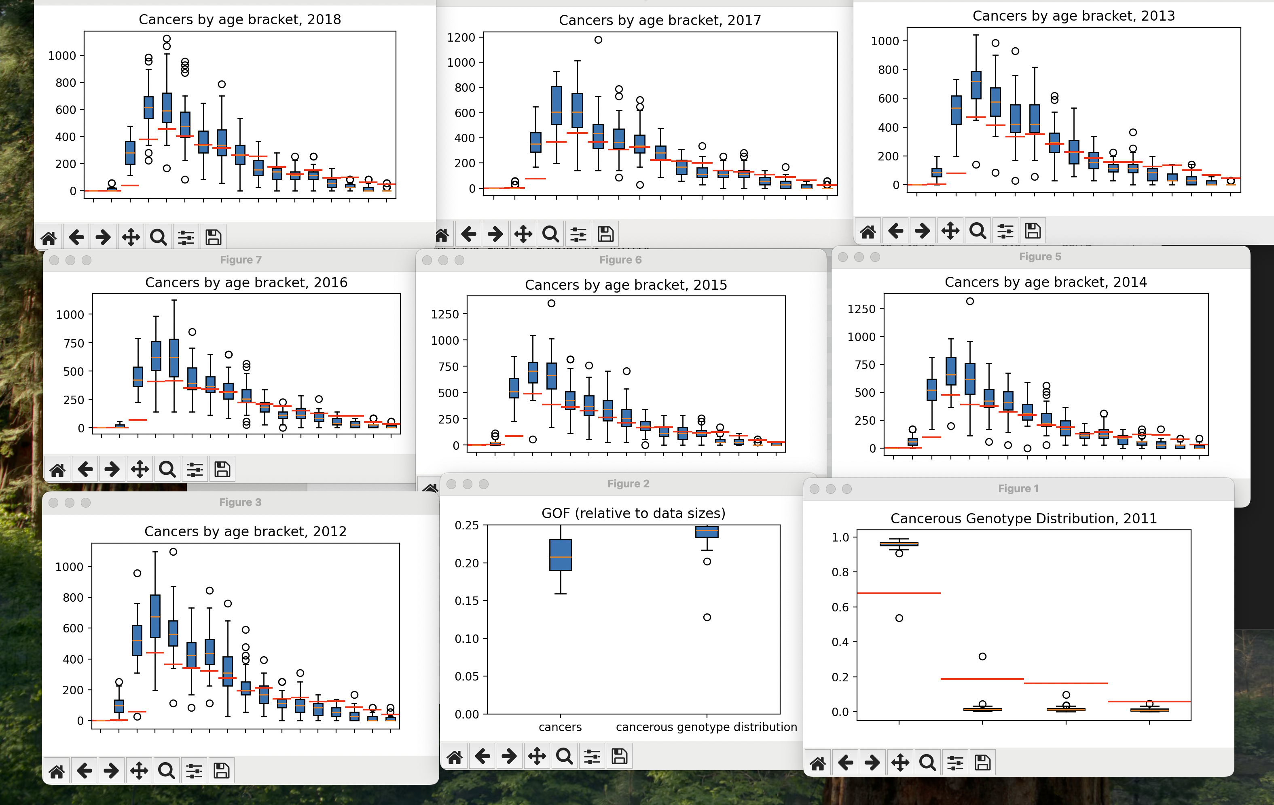
    - 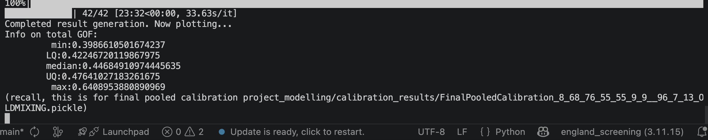
    - also, len(final_cal_data) is 42, so different… but I think we expected it to be different and in that way? So I am not too convinced this is doing to uncover a mix-up honestlys
    - .
    - Ok. Well we clearly see different trends with the different parameters so its nice that at least we don’t always end up wioth p[armeters that give basically the same output, but cruciually this is also a bad fit.
    - As it doesn’t look like I mixed them up,I now try a much more recent cal and see if I can at least sorta replicate the GOF there (with some margin – but not the crazy badness we see here!) – do FinalPooledCalibration_8_68_76_55_55_9_9__96_7_62.pickle (the SA on initial male HPV prev)
      - I am doing the same thing again with this cal and luckily I am getting total mismatches which are around 12ish. This is great. Now I will let this complete and then the issue is either that the calibrationEvbaluation scroipt was bad, or those initial cals were bad (in which case I will just work out which ones are screwed up and redo them)
      - Yup, here are the results and they are good!
      - 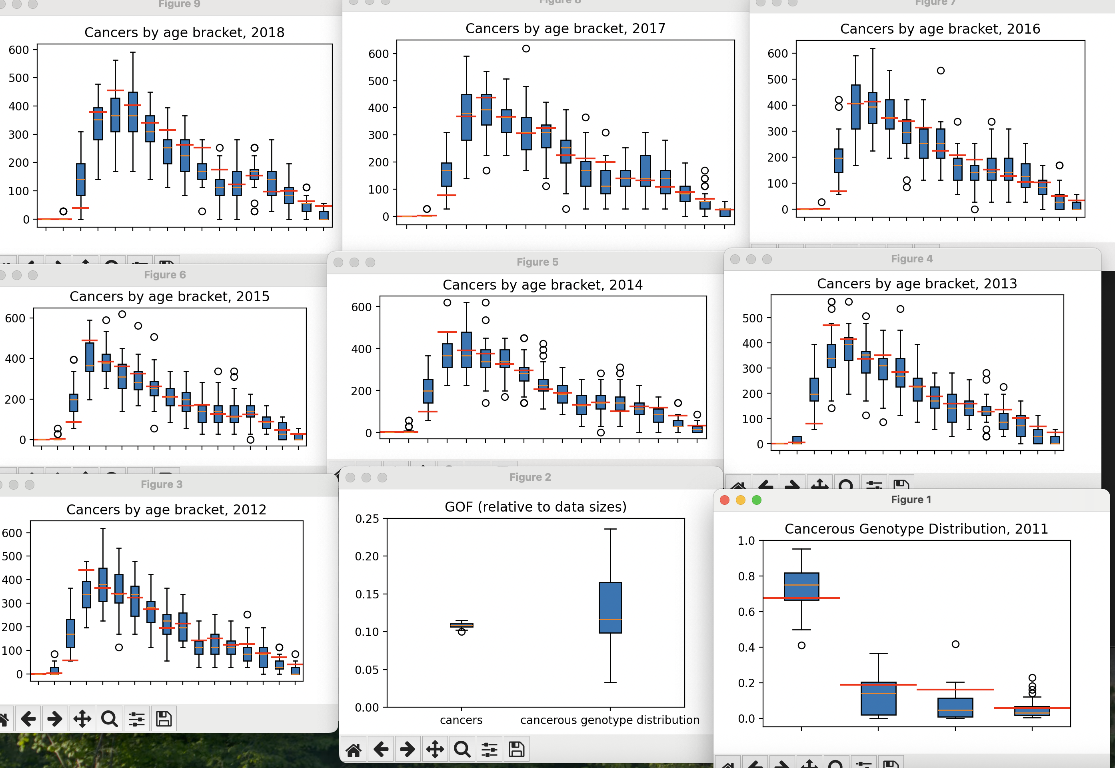
      - 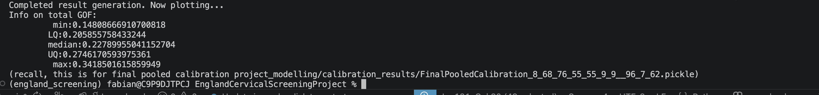

Now I can see that some of my calibrations are replicating the training performance nicely when being evaluated while the older ones (or at least one of the older ones) does not. This implies I have accidentally changed something that had a knock on effect, or at the very least I processed one of the cals wrong. I now am going to run this same sanity check, with a single eval run for each of the parameters in the finalpooledcalibration, for each of my completed FinalPooledCalibrations so far, to see which cals I need to unfortunately redo (red highlighting for redo needed, green highlighting for this finalpooledcalibration being all good for its sensitivity analysis, and non-highlighted meaning I still need to do this crude evaluation).
- FinalPooledCalibration_8_68_76_55_55_9_9__96_7_13_OLDMIXING
- FinalPooledCalibration_8_68_76_55_55_9_9__96_7_13
- FinalPooledCalibration_65_68_76_55_55_9_9__96_7_13
- FinalPooledCalibration_8_68_76_36_36_8_8__96_7_13
- FinalPooledCalibration_8_8_8_68_68_95_95__96_7_13 – one of its cals happened late enough to not be impacted, the others happened to soon so if i swap to the below being the key calibration I don’t lose much effort, just the cal on bmrc rn and on xps rn and
- FinalPooledCalibration_8_68_76_55_55_9_9__96_7_62

Then once I have done this I need to go over all of my parameters in the excel sheet and ensure it agrees with the model. I suppose either it agrees now and it didn’t with one/some of the first cals and I fixed it without realising I needed to redo something, or it doesn’t agree now but the fits are good so I should then make the excel agree with it because now it’s a consistently pretty great fit!
- Opperrtunity : if I am redoing a bunch of stuff there is something to be said about basing the sa on the male hpv prevalence matching female?
- Nah lets keep as-is
…oh its because I changed the implementation of screening algoriothms wasn’t it.. it was just unifying it but that does change things. Whoops. That was committed on 20th April, so I think any cals fully hjappening after 20th April should be ok?
- https://github.com/fabiansturman/HPVScreeningProject/commit/706be2ae0d62dac01013bcdf0c72e9ce3c8c7879 is the commit of whoopsies

